Valeri Paul

4.2 Async Notes

Database Template

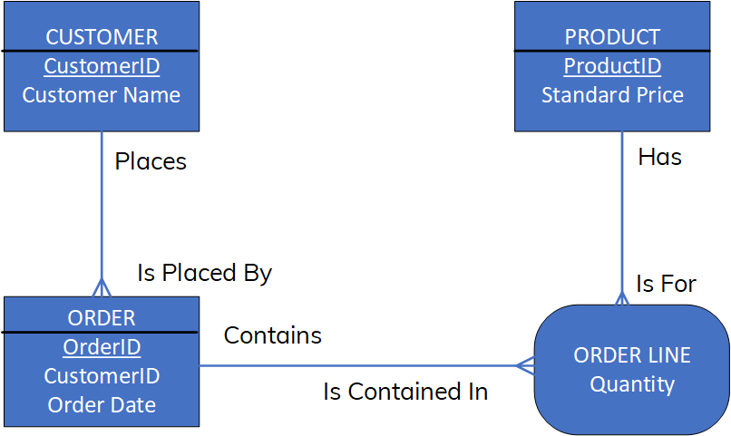

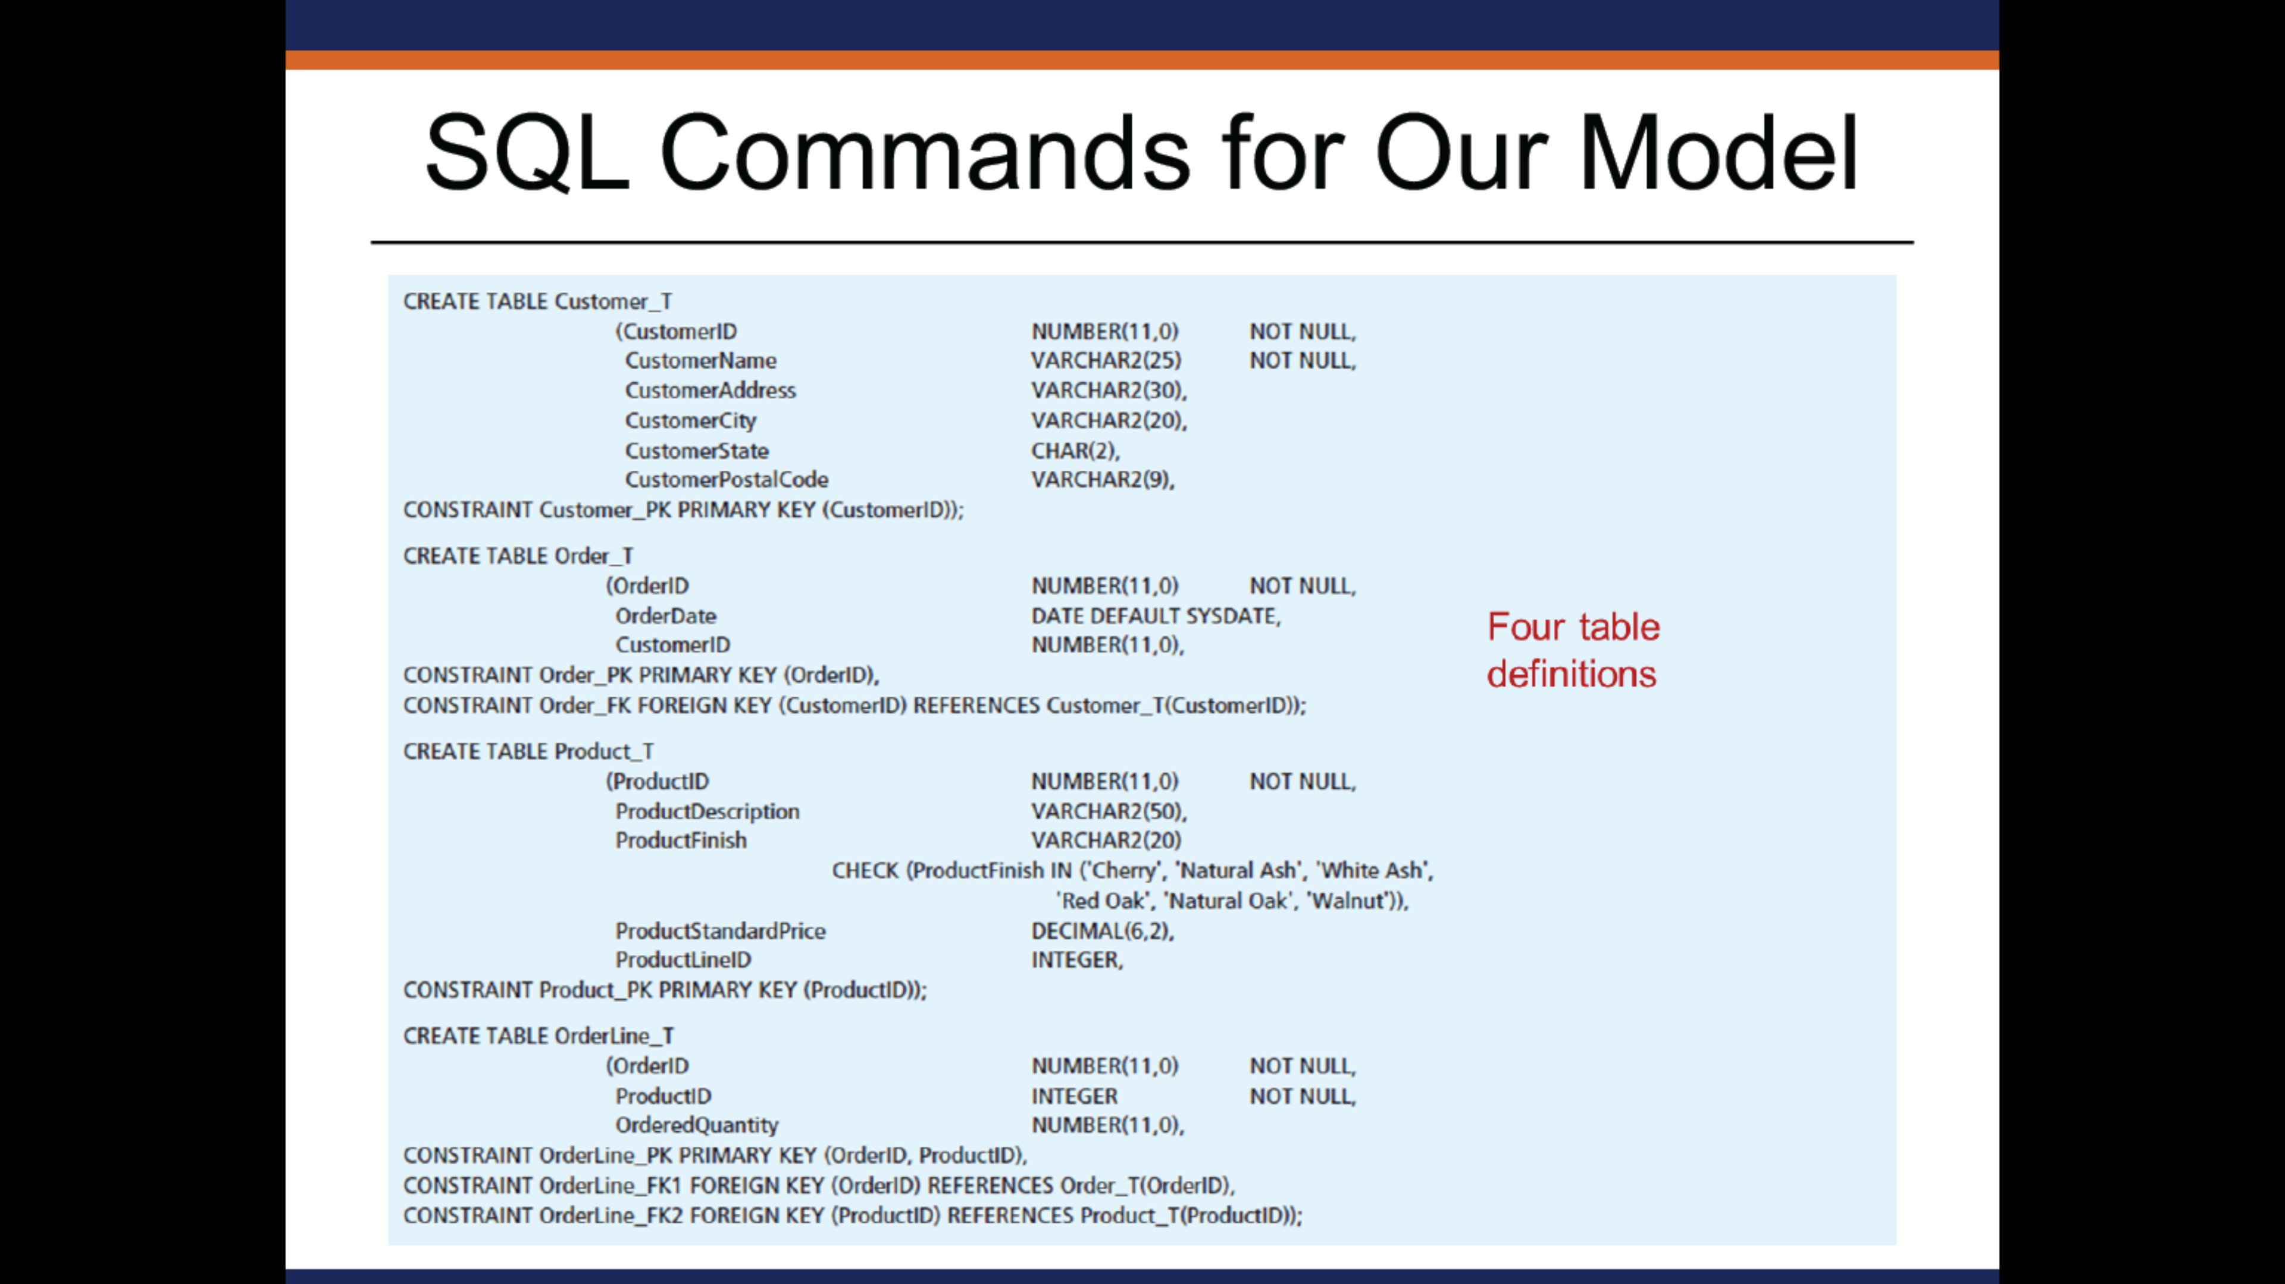

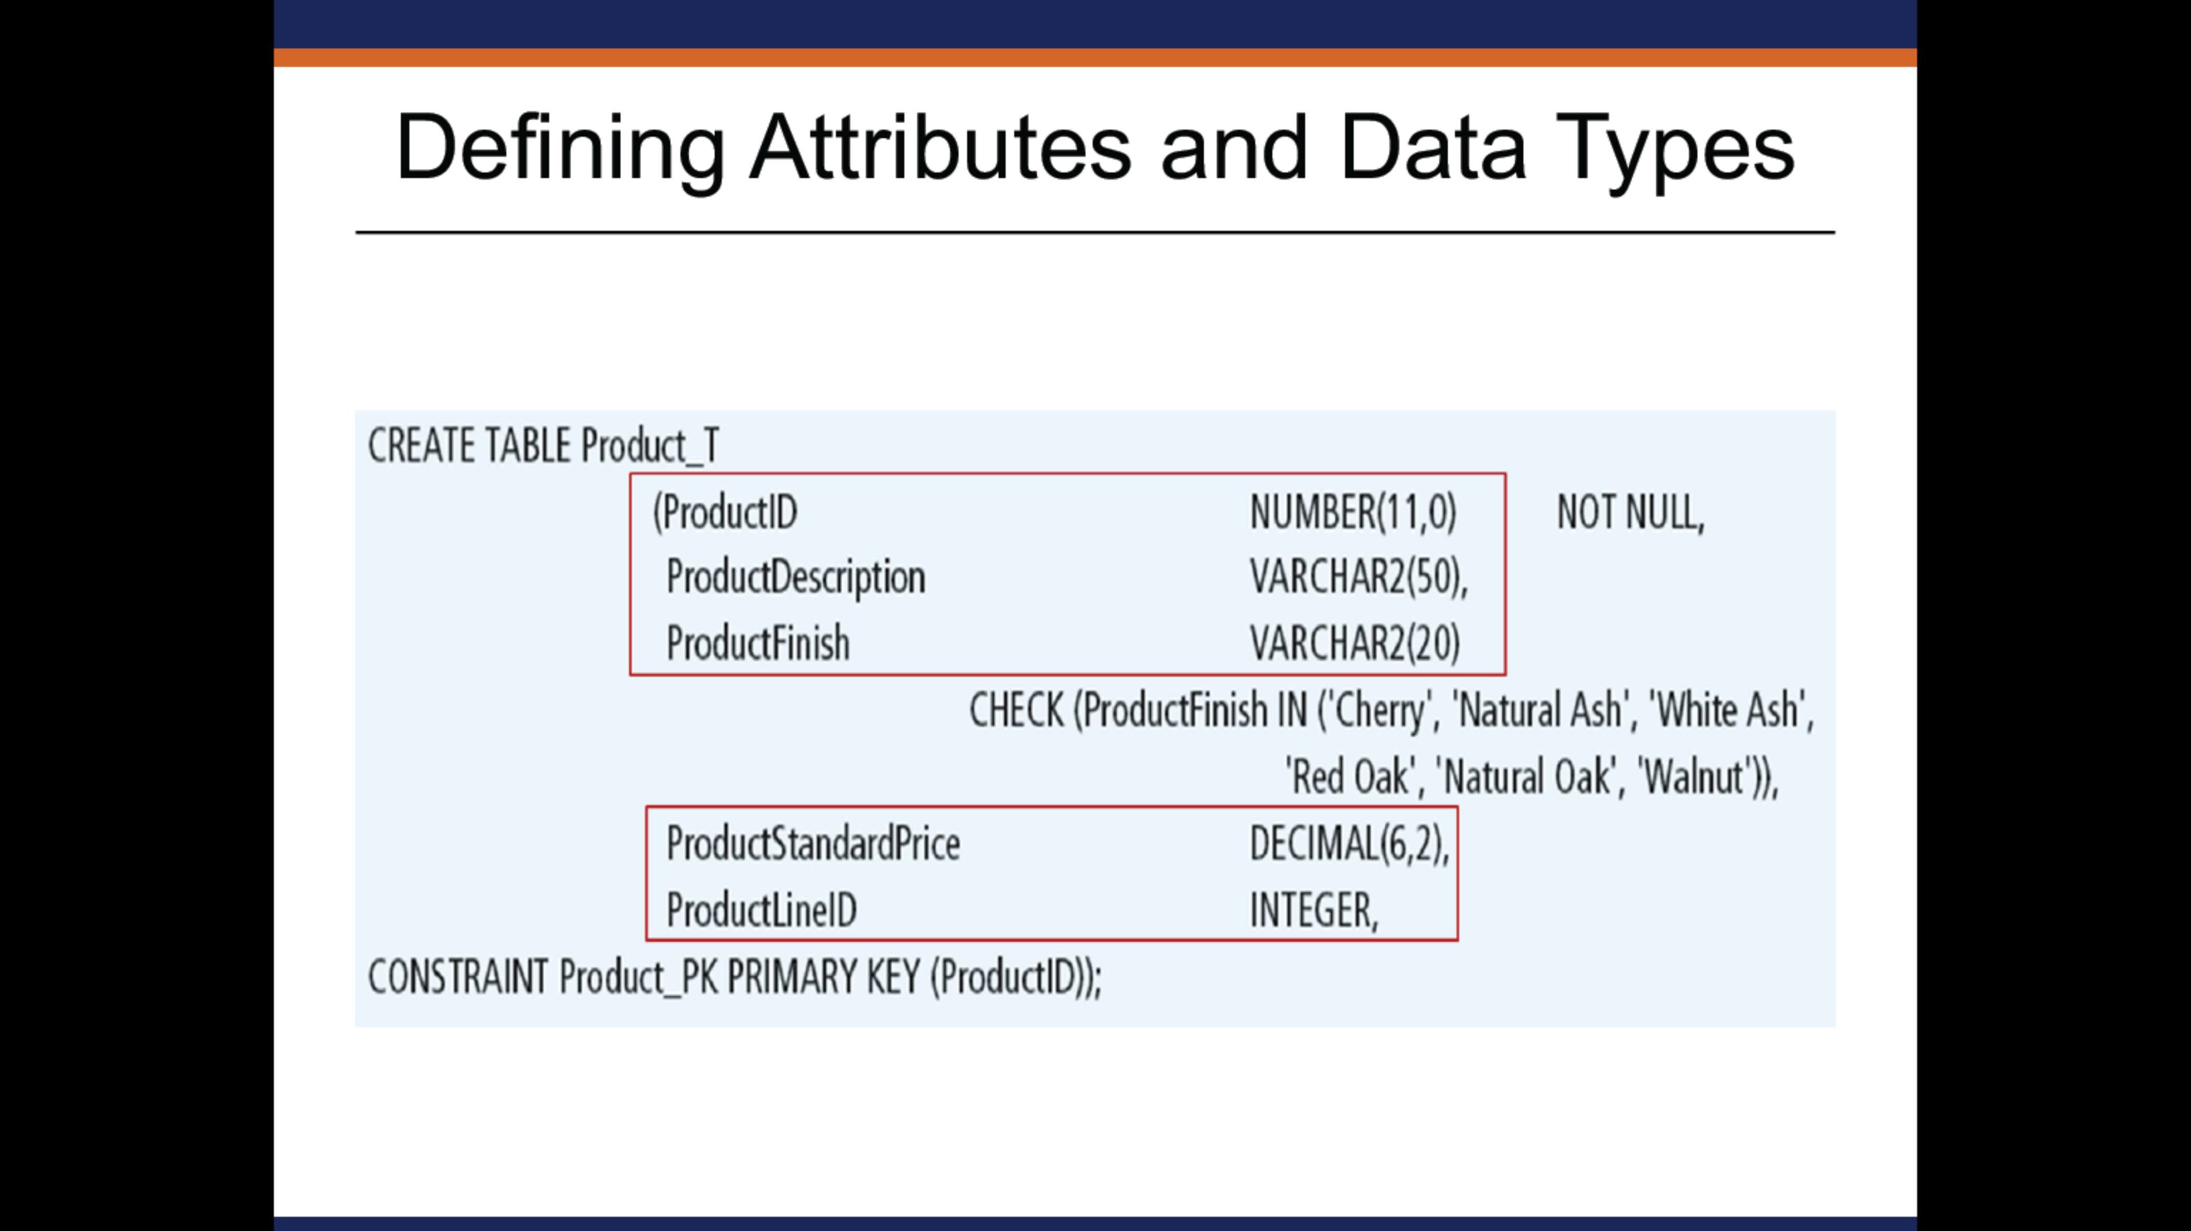

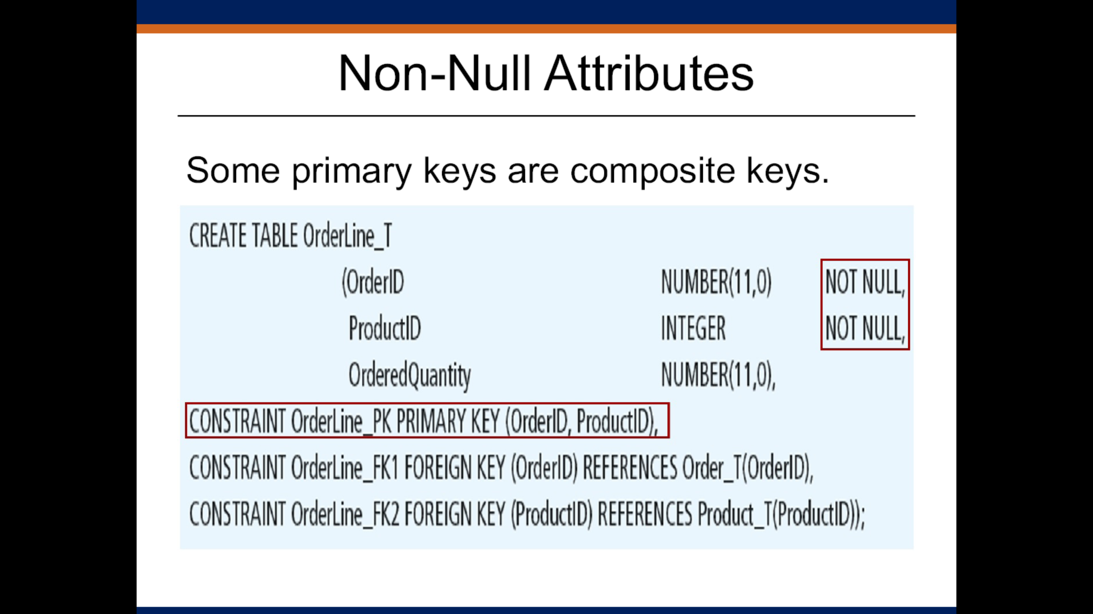

My SQL

CREATE TABLE "CUSTOMER_T" (

"CustomerID" NUMBER(11,0) NOT NULL,

"CustomerName" VARCHAR2(25) NOT NULL,

"CustomerAddress" VARCHAR2(30),

"CustomerCity" VARCHAR2(20),

"CustomerState" CHAR(2),

"CustomerPostalCode" VARCHAR2(9),

PRIMARY KEY("CustomerID")

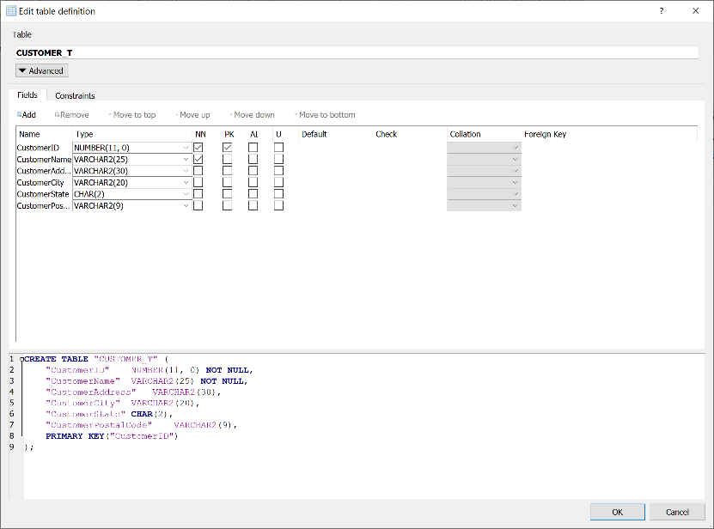)

CREATE TABLE "Product_T" (

"ProductID" NUMBER(11, 0) NOT NULL,

"ProductDescription" VARCHAR2(50),

"ProductFinish" VARCHAR2(20) CHECK("ProductFinish" IN ('Cherry', 'Natural Ash', 'White Ash', 'Red Oak', 'Natural Oak', 'Walnut')),

"ProductStandardPrice" DECIMAL(6, 2),

"ProductLineID" INTEGER,

CONSTRAINT "ProductID" PRIMARY KEY("ProductID")

)

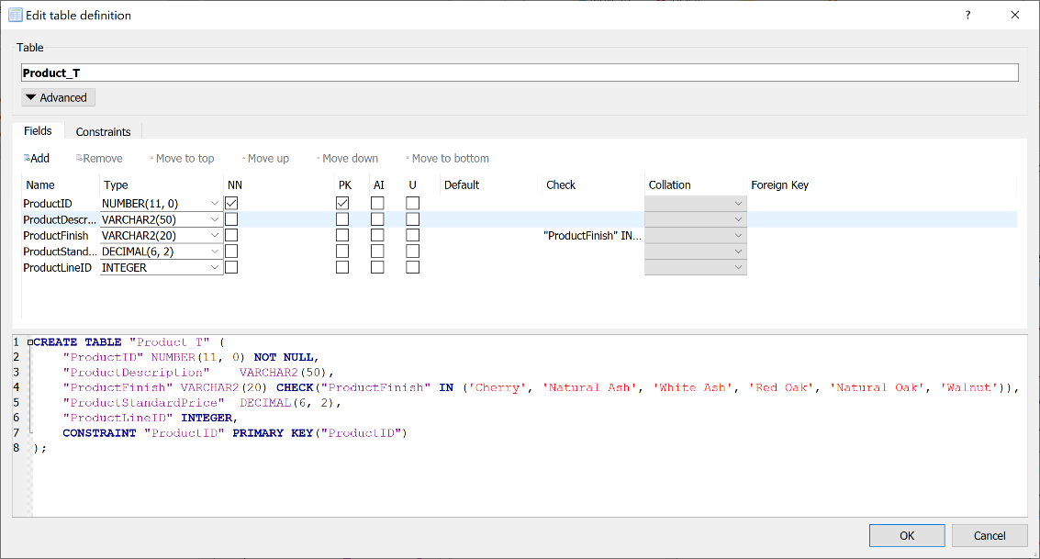

CREATE TABLE "Order_T" (

"OrderID" NUMBER(11,0) NOT NULL,

"OrderDate" DATE DEFAULT SYSDATE,

"CustomerID" NUMBER(11,0),

FOREIGN KEY("CustomerID") REFERENCES "CUSTOMER_T"("CustomerID"),

CONSTRAINT "Order_PK" PRIMARY KEY("OrderID")

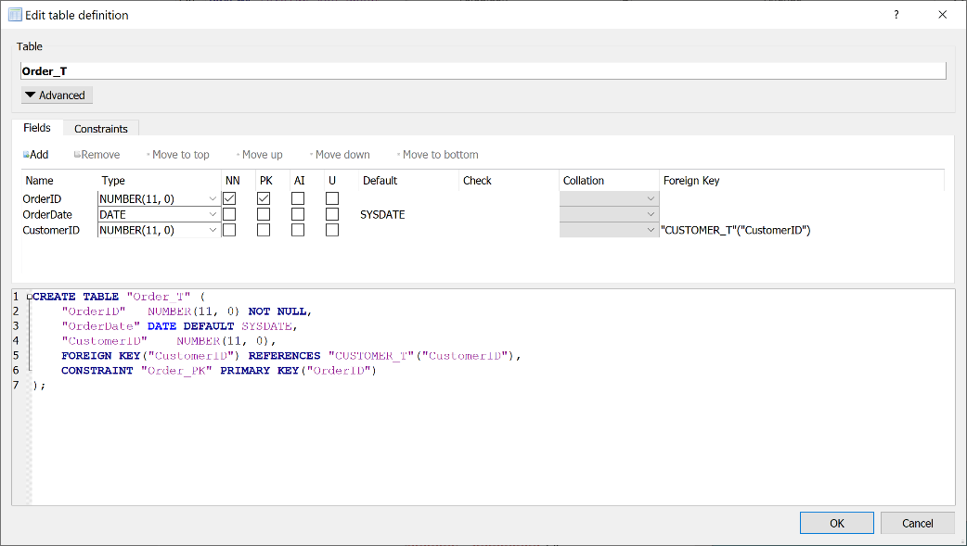)

CREATE TABLE "OrderLine_T" (

"OrderID" NUMBER(11, 0) NOT NULL,

"ProductID" INTEGER NOT NULL,

"OrderQuantity" NUMBER(11, 0),

FOREIGN KEY("OrderID") REFERENCES "Order_T"("OrderID"),

CONSTRAINT "OrderLine_PK" PRIMARY KEY("OrderID","ProductID")

)

